Lab #3

Brian Becker, Tony Mancuso, Jeremy McConaha

September 11, 2012

Purpose:

The purpose of this lab was to familiarize students with multi-sim circuit simulation and to allow them the opportunity to gain experience in re-creating circuits on the simulator. Selected circuits will be analyzed theoretically and hand calculations recorded. Multi-sim components will be placed, circuit wires will be attached, and measuring instruments will be applied. The simulation will be run and the theoretical values will be compared with simulated values.

Procedure:

1. Perform indicated calculations on given circuits.
2. Build Multi-sim circuit.
3. Run Simulation.
4. Compare Results.

Design and Theoretical Calculations:

Circuit 1:

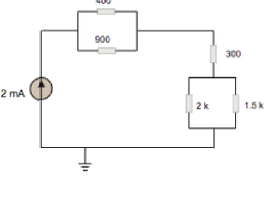 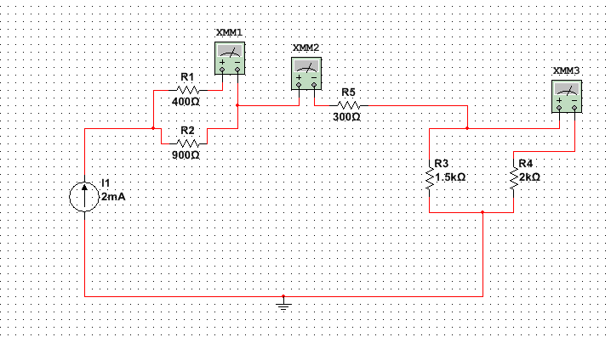

Circuit 2:

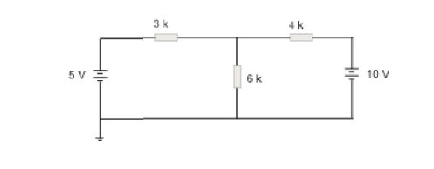

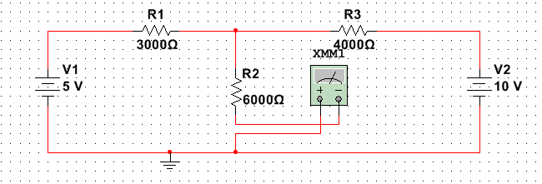

Circuit 3:

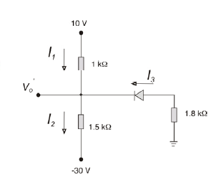

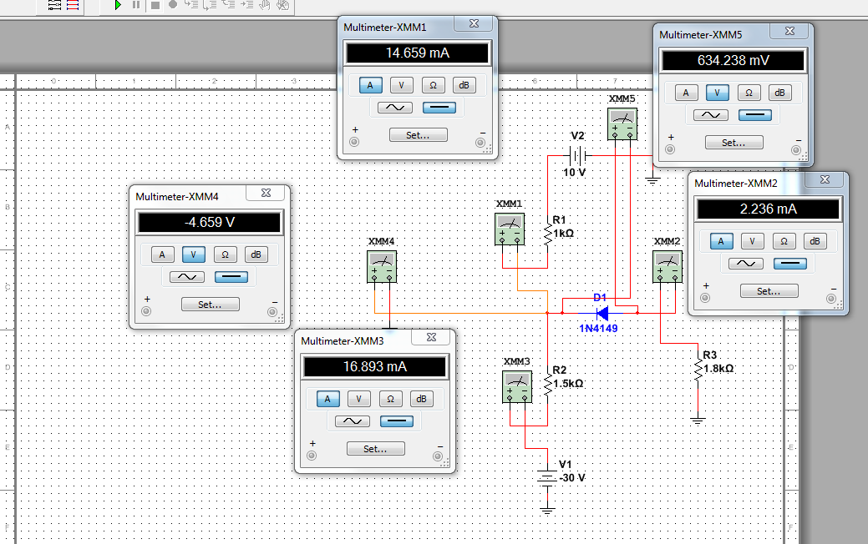

Handwritten Calculations:

Circuit 1:

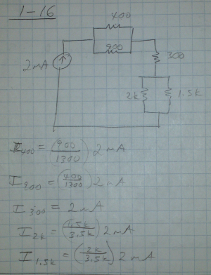

Circuit 2:

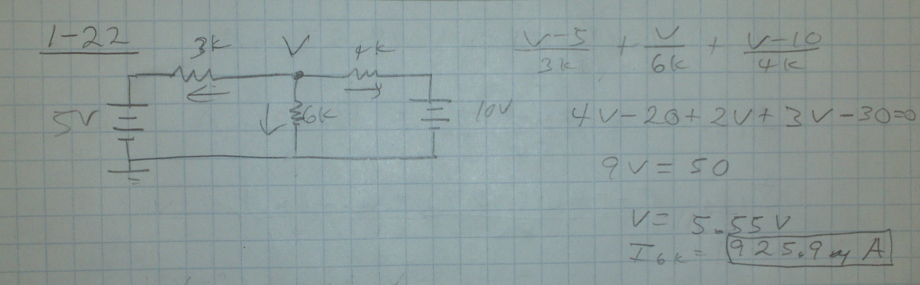

Circuit 3:

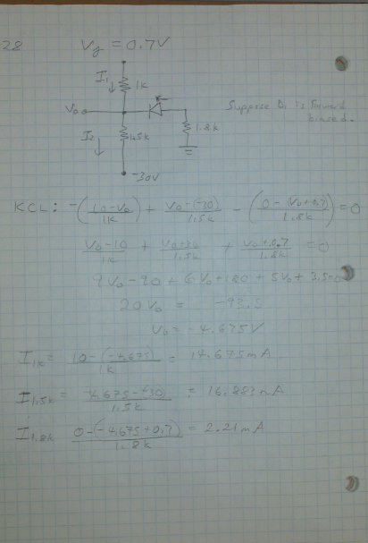

Results:

Circuit 1 and circuit 2 hand calculations matched the simulation values in multi-sim exactly. Circuit 3 had a slight discrepancy due to the fact the diode (1n4149) had a forward biased voltage of 635.24\*10^3V. However in our hand calculations we used an ideal value 0.7V.

Conclusion:

Multi-sim is a useful analytical tool. It can be used to simulate circuits prior to hardware implementation and can also serve as a verification of manual circuit calculations.